Intern Performance Analytics & Insights Dashboard
Sprint-3 Completion Report
KPI Definition & Dashboard Development

Project Overview
This project focuses on analyzing internship data using an interactive dashboard developed in Microsoft Power BI.
The objective is to understand intern performance, attendance behavior, engagement patterns, and certification outcomes through data visualization and exploratory data analysis.

Project Objective
- Analyze intern performance trends
- Evaluate attendance impact on performance
- Identify certification success factors
- Understand internship domain participation
- Support data-driven decision making

TOOLS USED
- Excel → Data preparation
- Power BI → Visualization

Dashboard Pages
Page 1 — Intern Overview Dashboard
- KPI summary metrics
- Attendance vs Performance analysis
- Domain distribution
- Gender participation analysis
Insight: Provides overall internship performance snapshot.
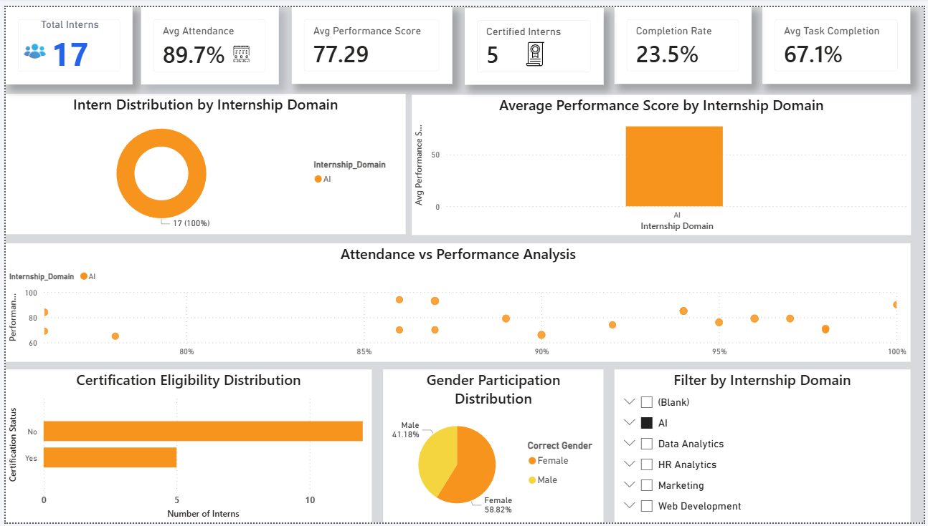

Page 2 — Intern Journey Analysis
- Internship completion trend
- Work mode distribution
- Weekly intern participation
- Experience level analysis
Insight: Tracks intern learning journey and engagement patterns.
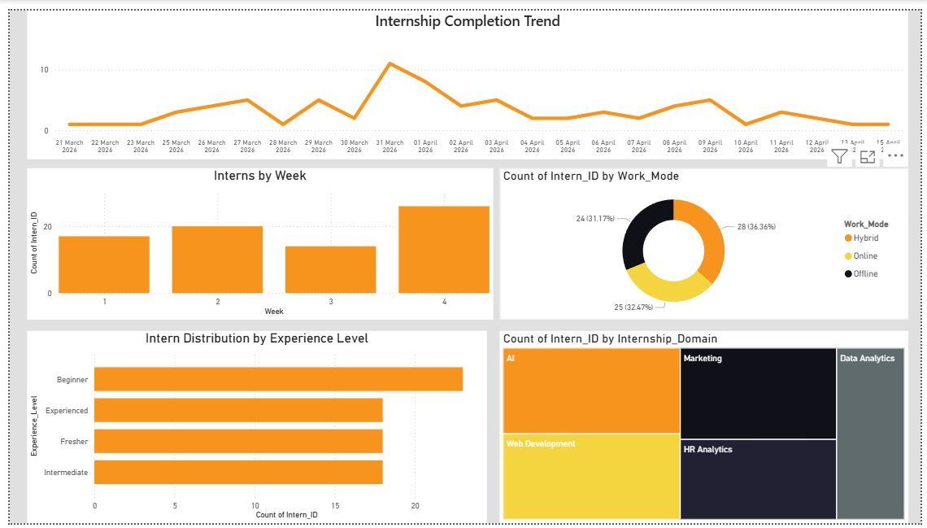

Page 3 — Performance Analysis & Key Drivers
- Performance distribution
- Weekly performance trend
- Task completion vs performance relationship
- Mentor feedback evaluation
Insight: Identifies factors influencing intern performance.
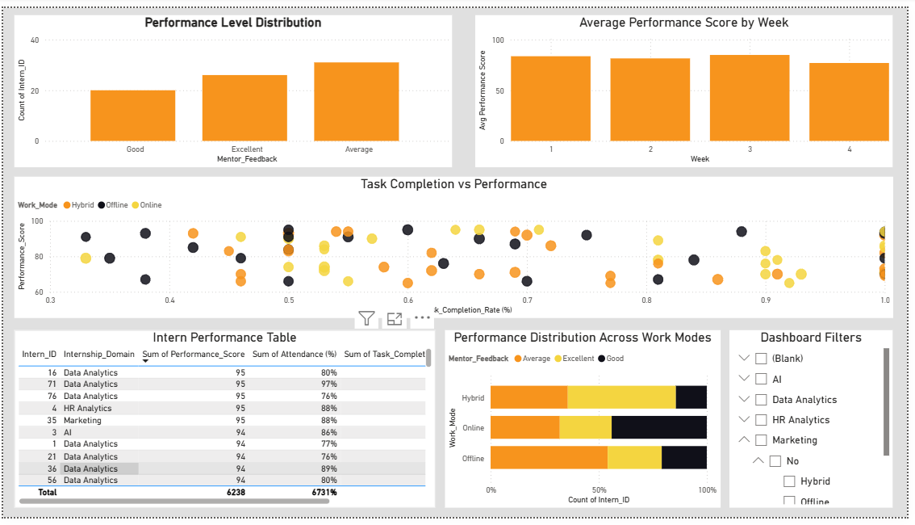

Page 4 — Key Insights & Program Impact
- Certification success analysis
- Attendance impact on certification
- Top performing domains
- Performance leaderboard
Insight: Measures effectiveness of internship program.
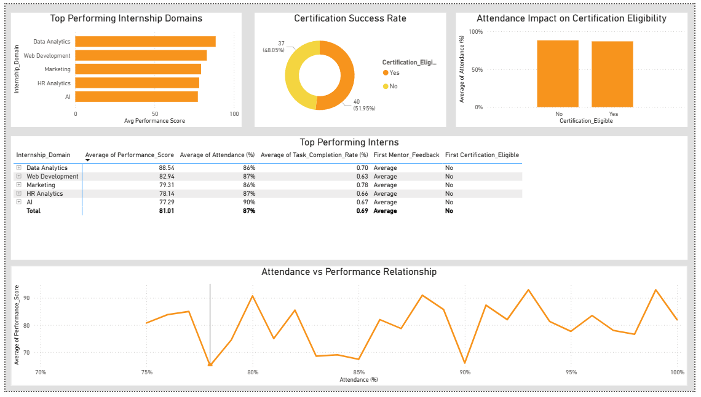

Page 5 — Final Insights Dashboard
- KPI summary cards
- Certification gauge
- Decomposition tree analysis
- Root cause identification
Insight: Supports strategic decision-making.

Key Outcomes
- Converted raw internship data into meaningful insights
- Built interactive multi-page dashboard
- Performed end-to-end exploratory data analysis
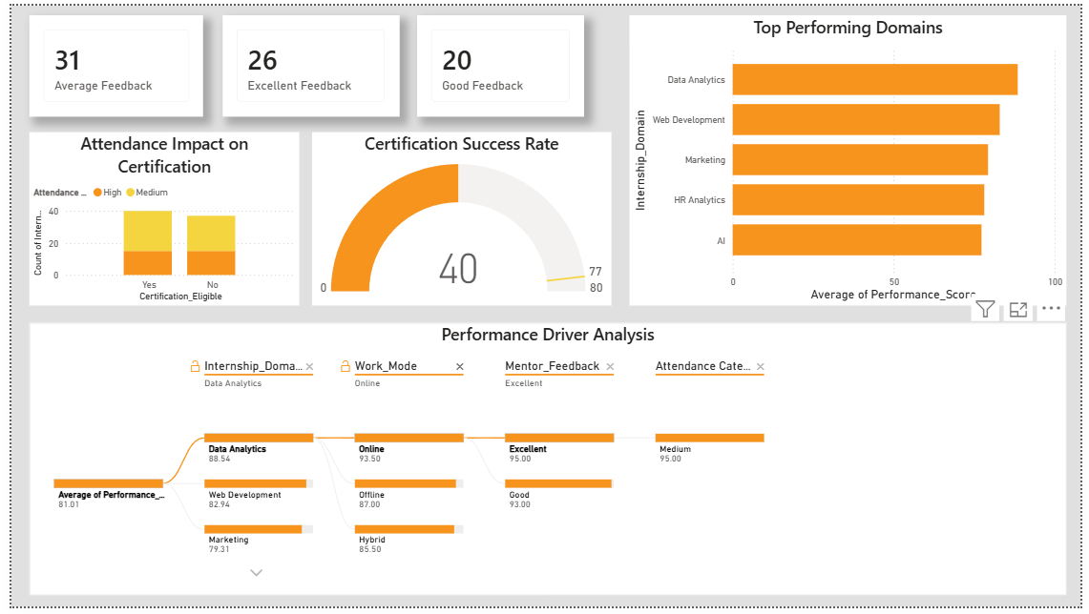
- Enabled performance monitoring and analysis

Sprint Information
Sprint 3: Dashboard Development & Visualization
Conclusion
This dashboard helps organizations monitor intern engagement, performance trends, and certification success using visual analytics.

